5. React-JS HOL

Name:- Shubham Sangram Bej

Hands-on 5

Objective
- Understand the need for styling React Components.
- Apply styles using CSS Modules.
- Use inline styles for conditional formatting.
- Style React components using className and style properties.

Software Requirements
- Node.js
- npm
- React
- Visual Studio Code

Project Name
cohorttracker

Procedure
- Created a new React application named cohorttracker.
- Created a component named CohortDetails.js.
- Created a CSS Module file named CohortDetails.module.css.
- Defined the box CSS class with:
  - Width of 300px
  - Inline-block display
  - Margin of 10px
  - Padding of 10px (top/bottom) and 20px (left/right)
  - 1px solid black border
  - Border radius of 10px
- Styled the <dt> HTML tag using a tag selector with a font weight of 500.
- Imported the CSS Module into the CohortDetails component.
- Applied the box class using the className property.
- Used inline styling to display:
  - Green color for Ongoing cohorts.
  - Blue color for all other cohorts.
- Displayed the cohort details in card format.
- Executed the application using:
npm start
- Verified the output in the browser.

Output
The application successfully displays the details of all cohorts in separate cards with appropriate styling. The cohort status is highlighted using different colors based on its current status.
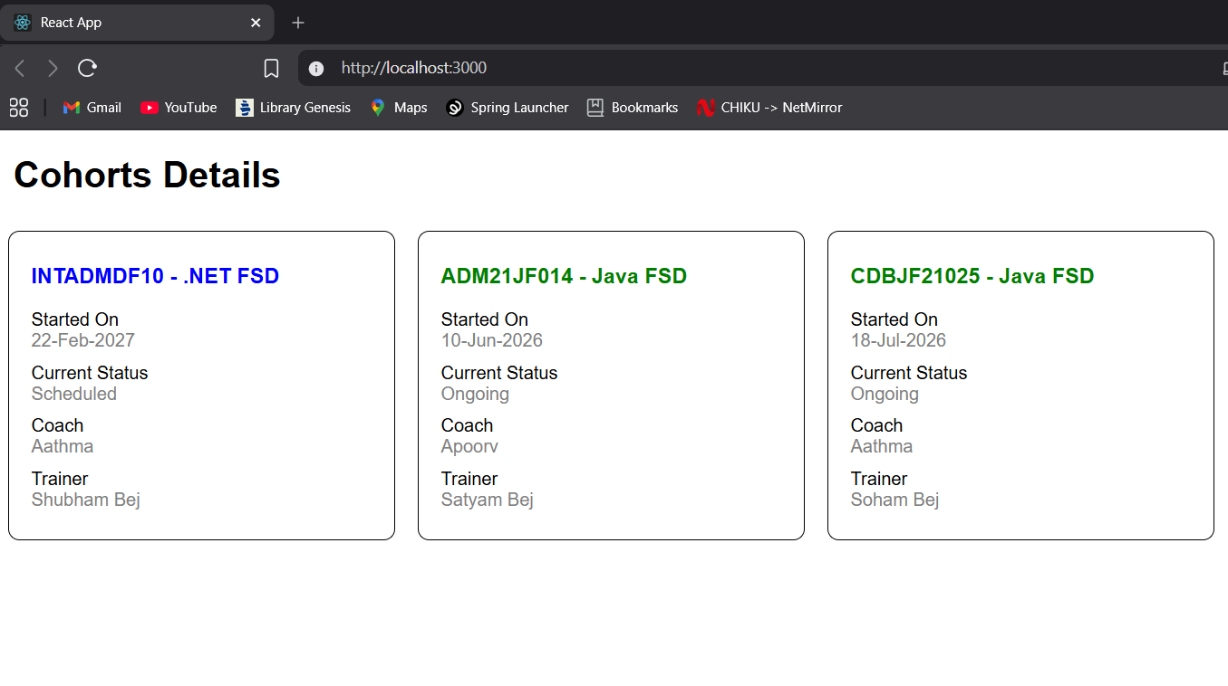

Result
The React application cohorttracker was successfully developed. CSS Modules and inline styling were implemented successfully to style the React components.

